Central Tendency

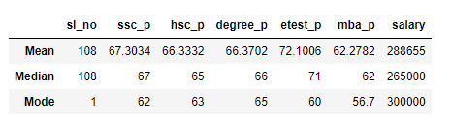

By reviewing mean, I have observed the below

Students are having average mark of “67” in 10th

Students are having average mark of “66” in 12th

Students are having average mark of “66” in ug

Students are having high than the average mark of “72” in E test

Students are having average mark of “62” in pg

So they are getting average salary of 288655.

By reviewing median, I have observed the high different in salary so it having outlier.

And for mode the salary of 300000 is repeated so the most of them having 300000 salary.